Problem Statement:02
To implement an Android application using resource files to dynamically modify displayed text and background color through user interaction.
Project Configuration (IMPORTANT)
Fill exactly like this (you may change app name slightly):
- Name: ResourceDemoApp
- Package name: auto-generated (leave it)
- Save location: default
- Language: Java
- Minimum SDK: API 21 or above
Click Finish
Wait till Gradle build completes.
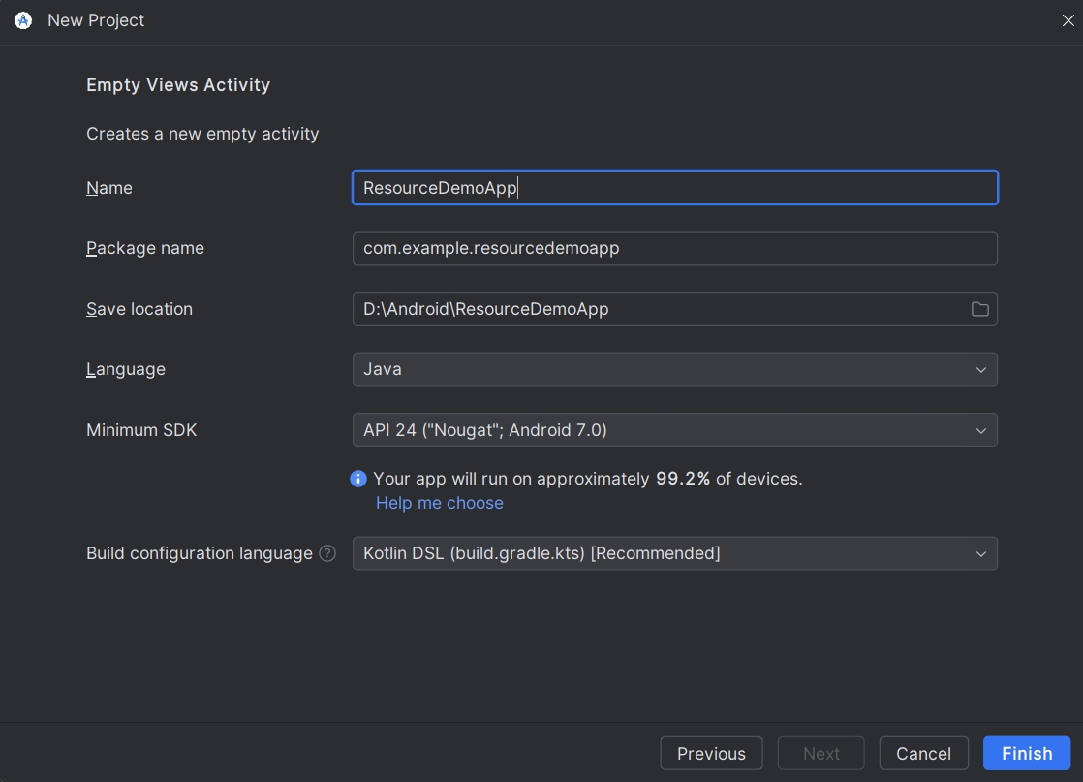
Step3: Open:
res → values → strings.xml
(SETUP STRING RESOURCES)
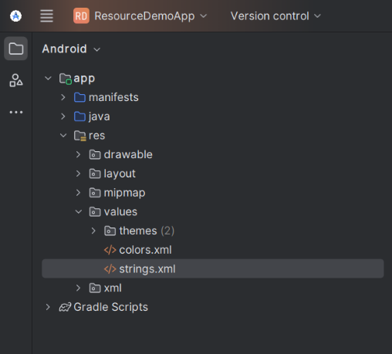
Code:
<resources>
<string name="app_name">ResourceDemoApp</string>
<!-- Text shown on screen -->
<string name="light_mode_text">Welcome to Resource Demo</string>
<string name="dark_mode_text">Dark Mode Activated</string>
<!-- Button labels -->
<string name="btn_dark">Switch to Dark Mode</string>
<string name="btn_light">Switch to Light Mode</string>
</resources>
Step:04
res → values → colors.xml
Code:
<resources>
<color name="light_background">#FFFFFF</color>
<color name="dark_background">#222222</color>
<color name="light_text">#000000</color>
<color name="dark_text">#FFFFFF</color>
</resources>
Step:05
res → layout → activity_main.xml
Replace everything with this:
<?xml version="1.0" encoding="utf-8"?>
<RelativeLayout
xmlns:android="http://schemas.android.com/apk/res/android"
android:id="@+id/main_layout"
android:layout_width="match_parent"
android:layout_height="match_parent"
android:background="@color/light_background">
<TextView
android:id="@+id/tvMessage"
android:layout_width="wrap_content"
android:layout_height="wrap_content"
android:text="@string/light_mode_text"
android:textSize="22sp"
android:textColor="@color/light_text"
android:layout_centerInParent="true"/>
<Button
android:id="@+id/btnToggle"
android:layout_width="wrap_content"
android:layout_height="wrap_content"
android:text="@string/btn_dark"
android:layout_centerHorizontal="true"
android:layout_alignParentBottom="true"
android:layout_marginBottom="50dp"/>
</RelativeLayout>
Step6:Locate: java → your.package.name → MainActivity.java
Code:
package com.example.resourcedemoapp;
import androidx.appcompat.app.AppCompatActivity;
import android.os.Bundle;
import android.widget.Button;
import android.widget.RelativeLayout;
import android.widget.TextView;
public class MainActivity extends AppCompatActivity {
boolean isLightMode = true;
@Override
protected void onCreate(Bundle savedInstanceState) {
super.onCreate(savedInstanceState);
setContentView(R.layout.activity_main);
RelativeLayout mainLayout = findViewById(R.id.main_layout);
TextView tvMessage = findViewById(R.id.tvMessage);
Button btnToggle = findViewById(R.id.btnToggle);
btnToggle.setOnClickListener(v -> {
if (isLightMode) {
// Switch to Dark Mode
mainLayout.setBackgroundColor(getResources().getColor(R.color.dark_background));
tvMessage.setText(getString(R.string.dark_mode_text));
tvMessage.setTextColor(getResources().getColor(R.color.dark_text));
btnToggle.setText(getString(R.string.btn_light));
isLightMode = false;
} else {
// Switch to Light Mode
mainLayout.setBackgroundColor(getResources().getColor(R.color.light_background));
tvMessage.setText(getString(R.string.light_mode_text));
tvMessage.setTextColor(getResources().getColor(R.color.light_text));
btnToggle.setText(getString(R.string.btn_dark));
isLightMode = true;
}
});
}
}
Now Run the App

